**ASTR 257 Project 1:**

**Measuring the Distance to Pluto with Nickel Astrometry**

**Overview**

In January 1930, Clyde Tombaugh, of Lowell Observatory, discovered Pluto by searching the sky for an object moving with sufficient speed that it must be located in our Solar System. By measuring how far Pluto moved with respect to background stars, Tombaugh was able to calculate its distance. We’re going to repeat Tombaugh’s experiment, except that we’ll know where to look, and we’ll have a modern telescope.

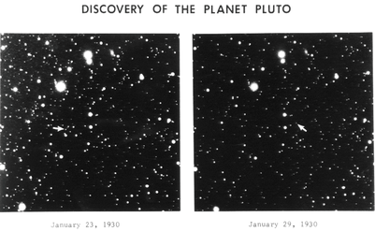

*Figure 1: Clyde Tombaugh’s discovery images of Pluto. Parallax causes the relatively nearby source to move when compared to more distant background objects. Tombaugh “blinked” two images taken a week apart to see the source move.*

Pluto moves on the sky because of parallax. As Earth moves around the Sun, nearby objects, such as Pluto, appear to change positions compared to far away objects, such as stars. Of course, Pluto orbits the Sun too, but with a quick calculation, you can show that Pluto’s apparent motion due to Pluto’s orbit is much less than Pluto’s apparent motion due to Earth’s orbit.

Although detailed geometric calculations are important for Solar System studies, we’ve got a lot to get through this week, so we’re going to keep things simple. Measure Pluto’s motion over the course of two nights. Determine its angular motion. Calculate its distance under the simplifying assumption that Earth and Pluto are on coplanar circular orbits with Earth’s orbit being responsible for Pluto’s apparent motion.

**Learning Objectives:**

* Students will learn to plan and execute imaging observations with the Nickel telescope.
* Students will learn the basics of astronomical data reduction with CCDs.
* Students will learn the basics of astrometry.
* Students will learn to present their observations in a standard written format that is appropriate for publication.

**Planning Your Observations**

***Where is Pluto in the Sky and When is it Observable?***

For Solar System bodies, a good place to get ephemeris tables (position vs. time) is the JPL Horizons database: <https://ssd.jpl.nasa.gov/horizons.cgi>. Try changing the object name and timespan and look up RA/Dec, which is what the Nickel telescope uses.

Next, let’s figure out when Pluto is observable. I use an ancient webtool called Airmass Calculator: <http://www.briancasey.org/artifacts/astro/airmass.cgi>, but there are a lot of tools that do the same thing. In Airmass Calculator, change the observatory name, make sure the date is correct, and type in the RA/Dec. Generally, I try to observe at <2.0 airmasses, but for objects that are really far South, we don’t always have a choice. This observation is pretty easy, so observing at higher airmass is OK, but telescopes usually have physical limitations (such as making sure the telescope doesn’t crash into the floor). Look this up on the Nickel webpage: <https://mthamilton.ucolick.org/techdocs/telescopes/Nickel/intro/>. (Note that whenever you’re using a new telescope, you have to get use to navigating their webpage, which can be a pain, but it’s part of the job.)

Now that we know Pluto’s coordinates and when we’ll be observing it, make a finder chart. This will help us verify when we observe Pluto that we’re actually seeing it. Again, there are different websites for doing this, but I generally use IRSA: <https://irsa.ipac.caltech.edu/applications/finderchart/>.

Type in the coordinates. Generate an image at approximately the wavelength you’ll be observing (in this case, visible). Make sure you know how big the image is and the cardinal directions (you can change the image size to match the field of view of the Nickel imager).

***How Bright is Pluto and How Long Should We Integrate?***

JPL Horizons should tell us approximately how bright Pluto is. If you want to see how bright Pluto will be compared to surrounding stars in your finder chart, IRSA may have a way of doing this, but I like the Keck AO guide star tool: <https://www2.keck.hawaii.edu/software/findChartV2/index.php>, which allows you to click on a star of interest. Again, there are many tools to do the same thing. Is Pluto relatively bright compared to nearby stars? Will you be able to recognize it quickly when you’re on-sky?

The main reason to know the brightness of your target is to figure out how long you need to integrate. Most observatories have pages that tell you what magnitude you can see with a given filter for a given integration length (e.g. <https://www.gemini.edu/sciops/instruments/niri/itc-sensitivity-and-overheads/sensitivity-tables-no-ao>). It looks like the Nickel doesn’t have this. We’re not learning signal-to-noise until tomorrow, so it’s OK to skip this check for now. Pluto is sufficiently bright that this won’t be very important. And, while exposure time calculators (ETCs) are a useful guideline one tends to adjust to the conditions when performing ground-based observing.

The last reason to know the brightness of Pluto is to make sure it doesn’t saturate the detector. Look up the Nickel’s detector saturation limit (also known as “well-depth”). The number will be in digital units as opposed to astronomical magnitudes, so again, this doesn’t help us in planning, but it’s good to know for when we observe. As a rule of thumb, lower your integration time so that you stay at or below half of the saturation limit unless the observatory webpage says otherwise. Note: this is in a *single* pixel, not for the integrated source counts. In fact, for very bright sources, one might de-focus the telescope to avoid saturation.

Note that if we were observing at Keck, we would really want to optimize our integration times before observing to keep from wasting time, and we would do this by emailing questions to Keck Observatory staff, doing detailed simulations of our expected data, or downloading archival data. At the Nickel, it’s OK to start out with ~10 second exposures, which we can increase if we don’t see Pluto, or decrease if we’re at risk of saturating.

***What Filter Should We Use?***

First, figure out what filters are available in the Nickel. At Mt. Hamilton, filters and gratings are exchanged daily in the instruments, and the configuration for our nights (which I requested when I wrote the telescope proposal) are listed on the telescope schedule. Filter wavelengths can be found on the Nickel website or if they are common filters, you could look on other observatory sites as well.

You should think about which filter will be most sensitive for Pluto. Also, keep in mind that if you’re observing near twilight or when the moon is out, the Earth’s atmosphere scatters blue light more than red light.

***What Calibrations Will We Need?***

Based on what we’ve learned about CCDs, what calibrations will we need? What integration times will we need for our calibrations and how many calibration images should we take? When should we take the calibration images?

***Using the Telescope and Instrument***

Read the Nickel website and its imager website as carefully as you can stand. There’s a checklist page and an [observing hints page](https://mthamilton.ucolick.org/techdocs/telescopes/Nickel/obsHints/) that is particularly useful. Write down, step-by-step, what you will need to do when you use the telescope. Even though this isn’t Keck, you want to be as efficient as possible running the instrument. And, you will find that these checklists are invaluable when it is 3am and you can barely remember your name. Last, the first night with a new instrument is always tough because you can’t easily try out the software in advance.

***Approval of Observation Planning***

Before we start observing, present your plan of *exactly* what you’ll be doing. The more detail the better.

**Night 1**

***Observatory Setup***

The first night, a support astronomer will help us set up the observatory. Pay careful attention as you will be doing it on your own during night 2.

***Observing***

Groups of 2-3 will take observations. You will point the telescope, find Pluto, take data, and download the data to make sure you got what you need. You will take calibrations either before the night or during the night depending on your plans. Most likely, the groups will alternate 10-minute slots. You might get everything you need in your first slot, or you might want to repeat some things in a later slot.

***Observing Logs***

The FITS files saved by the Nickel have image (pixel) data as well as meta-data, containing the instrument state, the telescope state, time, weather, etc. Nevertheless, it is always a good idea to keep your own log, containing information that might help you during the observing run (what integration times did I use last night?), or when you’re reducing your data. I suggest making an excel file, or google spreadsheet if you want to co-edit with your team, logging File #s, Object Name (including dark/flat), Time (UT), Filter, Integration Time, and Comments (including weather).

**Night 2**

If it worked on Night 1, do the same thing on Night 2. When you have two images from consecutive nights, blink them in [ds9](http://ds9.si.edu/site/Home.html) (or [Ginga](https://ginga.readthedocs.io/en/latest/)) to make sure you see Pluto. Night 2 we’ll also be doing the HR diagram, so try not to spend too much time repeating Pluto.

**To Be Completed During the Field Trip**

***Data Reduction***

Write a Python script to reduce your data using the standard calibration techniques we learned about in the CCD lecture. Identify Pluto. Use ds9 to measure how many pixels Pluto moved. Use the plate scale from the Nickel website to convert pixels into arcseconds.

***Calculate the distance to Pluto***

Assume coplanar circular orbits, assume that Pluto is at opposition (the Sun-Earth-Pluto make a straight line), and assume that Pluto’s apparent motion is dominated by Earth’s orbit as opposed to Pluto’s orbit. Calculate the distance to Pluto. How close are you to the right answer? If you have time, drop the assumption about Pluto being at opposition and redo the calculation using Pluto’s RA/Dec and the time of year to figure out the Sun-Earth-Pluto angle. If you don’t have time during the field trip, that’s fine. You can redo the calculation after the field trip when you do the write-up.

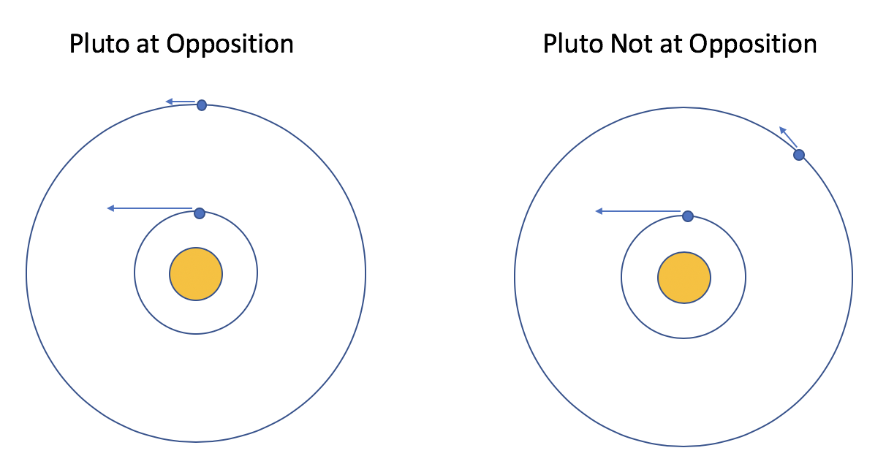

*Figure 2: At “Opposition”, the Sun, Earth and Pluto form a line. Earth is moving perpendicular to this line, which maximizes Pluto’s apparent angular motion compared to fixed background stars. When Pluto is not at opposition, its apparent angular motion is less. Pluto’s orbital motion, which is much slower than Earth’s orbital motion, is a second order effect on Pluto’s apparent angular motion.*

**Writeup (To Be Completed After the Field Trip)**

Read the Observations and Reductions sections of some example papers, which I will provide. Read my notes on how to write Observations and Reductions sections.

Write a report on Pluto with sections for Observations, Reductions, and Results. I expect your Observations section to be publication quality, your Reductions section to be clear, but not necessarily at the level of detail seen in publications, and your Results section to be extremely brief, just stating your distance estimate and how you derived it. Note that this observation of Pluto was relatively straight-forward, so I expect your Observations and Reductions sections to be shorter than the example papers I gave you. Brevity is a good thing as long as there is sufficient detail for someone to reproduce what you did.

Observations and Reductions section(s) need not sound like John Steinbeck. They are recipes where clarity is paramount. Most people will not read the Observations and Reductions sections of your paper but a few will and they will want to know *exactly* what you’ve done so that they could repeat the experiment themselves.